**Assignment 3 Instruction and Question Sheet**

**(Getting started with JavaScript)**

**(Total: 100 points)**

**Learning Objectives**

* Get familiar with basic JS instructions
* Get familiar with the three ways to apply JS to an HTML document
* Understand JavaScript runs where it is found in an HTML document
* Hands-on practice on how to add js code in an HTML document
* Explore details of using variables, dealing with numerical data and string data, and arrays

**Complete your assignment**

This assignment consists of 3 hands-on practices, you need to follow the instructions as below to complete practices, and type in your answers under each questions in this assignment instruction and question sheet. **The data files (CS381_A3.zip) needed for this assignment can be found in the Assignment-3 dropbox in Canvas course site.**

Download the zip file named “**CS381_A3.zip**” and then unzip the zip file. In the unzipped folder (by default with name “CS381_A3”), you will find 3 folders: **A3_Practice1, A3_Practice2, A3_Practice3.**

**Practice#1. [30 points]** Replace embedded JS with external JS. In ***A3_Practice1*** folder,

1. Open **mpg.html** in a text editor (e.g., Notepad++) and save it as **mpg_yourFirstNameLastName.html** (e.g., mpg_TinaCao.html)
2. In **mpg_yourFirstNameLastName.html**, move the embedded JavaScript code in this HTML document to a new external JS file. Save the external JS file as **mpg.js.**
3. Comment out the embedded JS code in **mpg_yourFirstNameLastName.html**, andadd a reference to the external JS file
4. Test **mpg_yourFirstNameLastName.html** (i.e., open it in a web browser) to make sure the external JS works the same way as the embedded JS code. For example, enter 30 in miles input box, and then press the ok button, and then enter 5 in gallons input box, and then press ok button, then you should see the output displayed in the web page as “The miles per gallon = 6.00”, which is generated by web browser.
5. Open **mpg_yourFirstNameLastName.html** in a web browser. What outputs will you see if you entered 30 in miles input box, and 0 in gallons input box? Fix this problem in JS code if you can.

Notice: watch the short video clip “JavaScript Tutorial For Beginners” (listed in Week-3 page in Class Schedule on Canvas course site) may help you understand the meaning of js code in this practice, for example, *prompt()* and alert() methods.

**Practice#2. [30 points]** Fix syntax error in JS code. Dealing with rounding error in floating-point arithmetic. In ***A3_Practice2*** folder,

1. Open **numeric-variable_problem.html** file in a web browser and then answer the following questions:
2. What are the text contents displayed in the web page?

*“Custom Signage” and “Cost will be determined soon”*

1. Where is the JavaScript part in that html file?

*Line 14 <script src="js/numeric-variable_problem.js"></script>*

1. Find and write down the error messages that you see in the console in your browser’s developer tool.

*Uncaught SyntaxError: Invalid or unexpected token*

1. Open **numeric-variable_problem.js** file in a text editor (e.g., NotePad++) and then answer the following questions:
2. Where is the syntax error in the JavaScript file?

*Having a number in a variable name 5weight*

1. Fix that error and reload the web page in browser. What is the change in the content displayed in the web page after fixing the syntax error in the JavaScript code?

*An unrounded dollar amount of $0.59500…1 replaces the cost text*

1. Replace the js statement: *el.textContent = '$' + total;* in the JavaScript code with *el.textContent = '$' + total.toFixed(3);* What is the change in the content displayed in the web page after fix the rounding error in floating-point arithmetic by using the toFixed() method?

*The unrounded dollar amount became $0.595*

**Practice#3. [30 points]** Working with Array. In ***A3_Practice3*** folder,

1. Open “**update-array2.html**” in your web browser, what are the text content displayed in the web page? What are the outputs displayed in the console area in the developer tool in your web browser?

*Colors: pink yellow beige,green,beige*

1. Add js code in “**update-array.js**” in lines 10, 11, 14, 15, and 19 as shown below and then save js file.

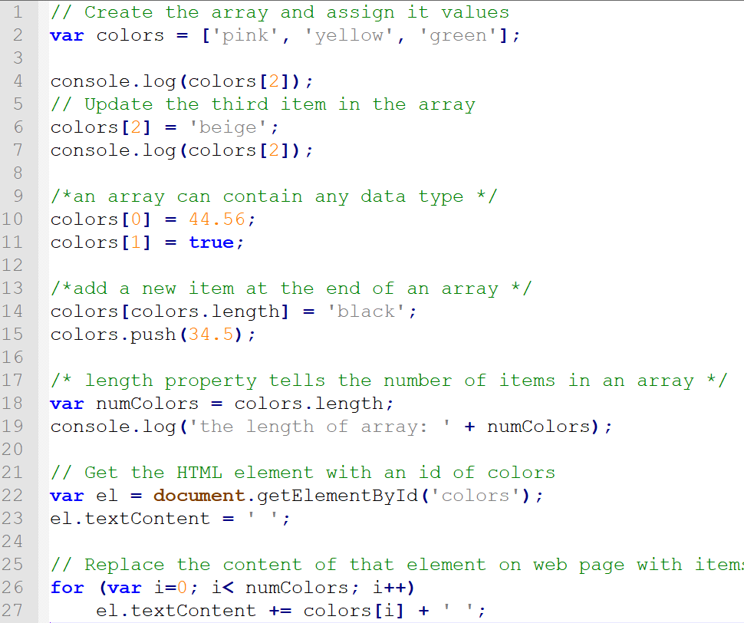



1. Reopen/Refresh “**update-array.html**” in your web browser, what are the text content displayed in the web page? What are the outputs displayed in the console area in developer tool in your web browser?

*Colors: 44.56 true beige black 34.5,green,beige,the length of array: 5*

**Submit your assignment [10 points]**

* After you complete, please **save and submit** this instruction and question sheet **with your answers** as “**A3_yourLastNameFirstName_answers.docx**”, and **save** all the files and folders in “CS381_A3” folder and then zip the “CS381_A3” folder. Renamed the zipped folder as “**A3_yourLastNameFirstName.zip**”, and then submit it to the assignment drop boxnamed **Assignment-3**.

***Note:*** If your computer does not have the ability to “zip” (i.e., compress or uncompress) files, download and use a free zip program such as 7-Zip (<http://www.7-zip.org/> )